Introduction to the directory

# Change the format of original data

If I read in the given 1.csv with code “pd.read_csv('1.csv', sep = '\\t', …)”, I would got the warning of “Falling back to the 'python' engine because the 'c' engine does not support regex separators”.

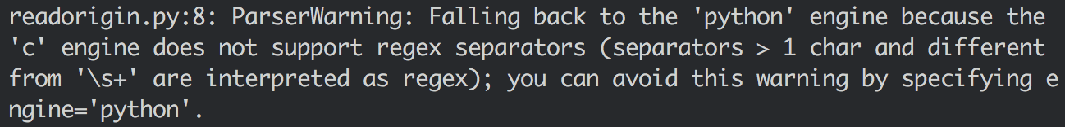

I want to use the 'c' engine, so in “readorigin.py” I transformed the given 1.csv to “,” separated “transformed.csv”.

# Use the given sample code get the sample result

I use the given sample code of the link <https://machinelearningmastery.com/time-series-forecasting-long-short-term-memory-network-python/> , get the result of RMSE = 58.08



I also add a function to get the MAPE value.

# Control randomness of the code

We do not want randomness while we adjust some parameters, and want to know the best configuration of parameters.

According the link <https://keras.io/getting-started/faq/#how-can-i-obtain-reproducible-results-using-keras-during-development> , I could get reproducible result.

The following code was added:

np.random.seed(42)

*# The below is necessary for starting core Python generated random numbers*

*# in a well-defined state.*

rn.seed(12345)

*# Force TensorFlow to use single thread.*

*# Multiple threads are a potential source of*

*# non-reproducible results.*

*# For further details, see: https://stackoverflow.com/questions/42022950/which-seeds-have-to-be-set-where-to-realize-100-reproducibility-of-training-res*

session_conf = tf.ConfigProto(intra_op_parallelism_threads=1, inter_op_parallelism_threads=1)

**from** keras **import** backend **as** K

*# The below tf.set_random_seed() will make random number generation*

*# in the TensorFlow backend have a well-defined initial state.*

*# For further details, see: https://www.tensorflow.org/api_docs/python/tf/set_random_seed*

tf.set_random_seed(1234)

sess = tf.Session(graph=tf.get_default_graph(), config=session_conf)

K.set_session(sess)

# Find the optimal parameter: number of neurons

Because the result is reproducible, I tested the number of neurons from 1 to 39 to find which number is more appropriate.

I made two attempts, one is 30-epoch turn, and another is 300-epoch turn, with the code “test_loop_whole.py”. The 30-epoch result is shown as following:



The result of 300-epoch is shown as following:



The results were also shown as .png files in png_result folder.

I choose the number of 30, as the number of neurons.

# Make multiple tests and get the result

Now we back to the code with randomness, using 30 as the number of neuron, and make a 30-turn test, using the code “test_multi.py”.

Following is the RMSE and MAPE value of each turn:



Statistical data of all turns:



RMSE date shown in box:

